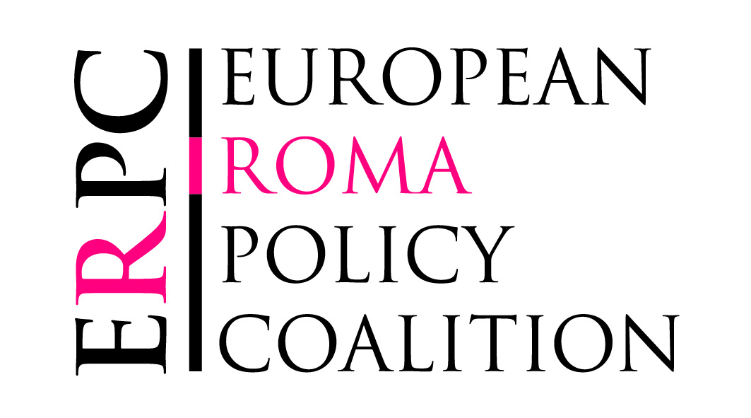
5 April 2011

ERPC Statement
“EU Roma Framework weak on discrimination against Roma”

The European Roma Policy Coalition (ERPC) acknowledges the European Commission’s political commitment to Roma inclusion expressed today by the adoption of its EU Framework for National Roma Integration Strategies. The Commission’s request to all Member States to develop and implement dedicated long-term strategies to promote Roma integration in four key areas – access to education, healthcare, employment and housing and essential services – and to allocate sufficient targeted resources to achieve progress, is a significant step forward.

However, the Framework falls far short of fully tackling the challenges of Roma exclusion, which are intimately linked to widespread hostility and discrimination against the Roma people. The ERPC is deeply disappointed that while the Framework recognizes the need to fight discrimination against Roma and ensure their equal access to all fundamental rights, it fails to specify measures to combat discrimination, intimidation, anti-Gypsyism, hate speech or violence against Roma. In this respect, the Framework is far from fulfilling last month’s recommendations of the European Parliament.

The ERPC is also concerned that despite the general failure of existing Roma inclusion policies to produce tangible results and many Member States’ lack of experience with such policies, the Framework offers no clear guidance for developing or implementing more effective national strategies. The Framework is too unambitious in some areas and fails to establish explicit targets for Member States, nor does it oblige them to collect relevant disaggregated data to allow proper monitoring and evaluation. The Framework also fails to present a clear coordination mechanism, which is crucial to ensuring full and effective engagement of the European Commission, Member States and civil society. Experience with the EU Roma Platform strongly suggests a total overhaul is necessary if it is to become an effective EU-wide coordinating mechanism for Roma policy discussion and assessment.

The ERPC calls on all Member States and EU accession countries to develop or adapt their strategies in close adherence to the ten Common Basic Principles on Roma Inclusion, in close consultation with Roma and pro-Roma civil society. The ERPC urges Member States to exceed the minimum thematic areas outlined in the Framework and to include actions to tackle and prevent discrimination and anti-Roma sentiment. The ERPC calls on the Commission, when it assesses national Roma integration strategies, to pay close attention to how Member States’ facilitate the active participation of Roma in all stages policy development and implementation as a crucial success factor, and to oblige Member States to progress towards explicit targets based on common indicators.

Despite its strong reservations, the ERPC calls on the European Council to endorse the Framework as establishing minimum common standards for Roma inclusion, and to stress Member States’ common responsibility for halting discriminatory practices and pursuing policies that guarantee equal opportunities to all citizens. The ERPC urges the Commission to fill the many gaps, as set out in the ERPC’s “Essential Elements”, notably regarding the establishment of a solid coordination and monitoring mechanism for the Framework and the process of assessing Member States’ national strategies, as well as governance mechanisms to ensure proper implementation and in developing policy proposals for the 2014-20 funding period.

The European Roma Policy Coalition is an informal gathering of non-governmental organisations operating at EU level on issues of human rights, anti-discrimination, anti-racism, social inclusion, and Roma and Travellers’ rights. Its members are Amnesty International, the European Roma Rights Centre, the European Roma Information Office, the Open Society Institute, European Network Against Racism, Minority Rights Group International, the European Roma Grassroots Organizations Network, Policy Center for Roma and Minorities, the Roma Education Fund, and Fundación Secretariado Gitano.
Contact: coordination@romapolicy.eu - for enquiries: ERGO Network +32 497 39 32 17

